

User Manual

DVTk Query SCP emulator R4.1.0

*A DVTk based tool*

Document version 1.1

August 25, 2011

**Table of Contents**

1 Introduction 3

1.1 Revision History 3

1.2 General 3

1.3 System Requirements 3

1.3.1 Operating system 3

1.3.2 Software requirements 4

2 Software installation 4

2.1 Installation of DVTk Query Retrieve SCP Emulator software 4

3 Functional description of the SCP emulator 5

3.1 Menu bar 5

3.2 Tool Strip 6

3.3 Information Screen Selection 7

3.3.1 Configuration 7

3.3.2 Move Destinations 10

3.3.3 Edit DCM Files 11

3.3.4 Logging 12

3.3.5 Validation results 13

3.3.6 Store Files functionality 14

4 Supported DICOM SOP Classes 16

5 Supported transfer syntaxes 20

# ****Introduction****

## Revision History

|  |  |  |
| --- | --- | --- |
| **Version** | **Date** | **Description** |
| 1.0 | April 11, 2011 | First version of this document, describing the functionality of DVTk Query Retrieve SCP Emulator version R4.0.2 |
| 1.1 | August 25, 2011 | Added information about the new features |

## General

The DVTk Query Retrieve SCP Emulator application handles C-FIND and C-MOVE requests from remote applications. The QR responses are emulated using the DICOM files indicated by the user. A brief description of the capabilities of the Emulator is given below.

* Supports queries based on the following Information Models
* Patient Root Query/Retrieve Information Model
* Study Root Query/Retrieve Information Model
* Patient/Study Only Query/Retrieve Information Model
* Configurable Transfer Syntax Selection
* Possibility to generate random digits in attribute values (e.g. for creating unique ID's) every time the Query/Retrieve emulator is started.
* Supports Case sensitive Queries on attributes of the following VRs.
* Application Entity(AE)
* Code String(CS)
* Short String(SH)
* Patient Name(PN)
* Long String(LO)
* Configurable Move Destinations.

## System Requirements

### Operating system

The following operating systems are supported:

* Windows 2003 Server
* Windows XP Professional
* Windows Vista
* Windows 7

### Software requirements

The following packages are required for the installation of the software packages:

* Microsoft .NET framework 2.0
* DVTk Definition Files

The Microsoft .NET framework software package is included in the installer of the **DVTk Query Retrieve SCP emulator** tool.

See: <http://www.dvtk.org> for new versions and features.

# Software installation

All the steps of the installation process are controlled by the DVTk Query Retrieve SCP emulatorinstaller package. During the installation process, the installer will check if the Microsoft .NET Framework R2.0 is already installed on the system. The user will have to download the .NET framework and install it if it is not present. If present, this step of the installation process will be skipped.

## Installation of DVTk Query Retrieve SCP Emulator software

1. Download the installer **Query Retrieve SCP Emulator 4.0.2 .msi** to a temp directory on the PC.
2. Start the installation procedure by double clicking with the left mouse button on the file Query Retrieve SCP Emulator 4.0.2.msi.
3. Follow the instructions of the installer.

In windows “All programs” there is an entry created “DVTK”. When selecting DVTK, a submenu with all installed DVTK applications will be opened. From this submenu the Query Retrieve SCP Emulator tool can be selected and started.

# Functional description of the SCP emulator

In the screen capture below, the User Interface of the Query Retrieve SCP Emulator tool is shown:

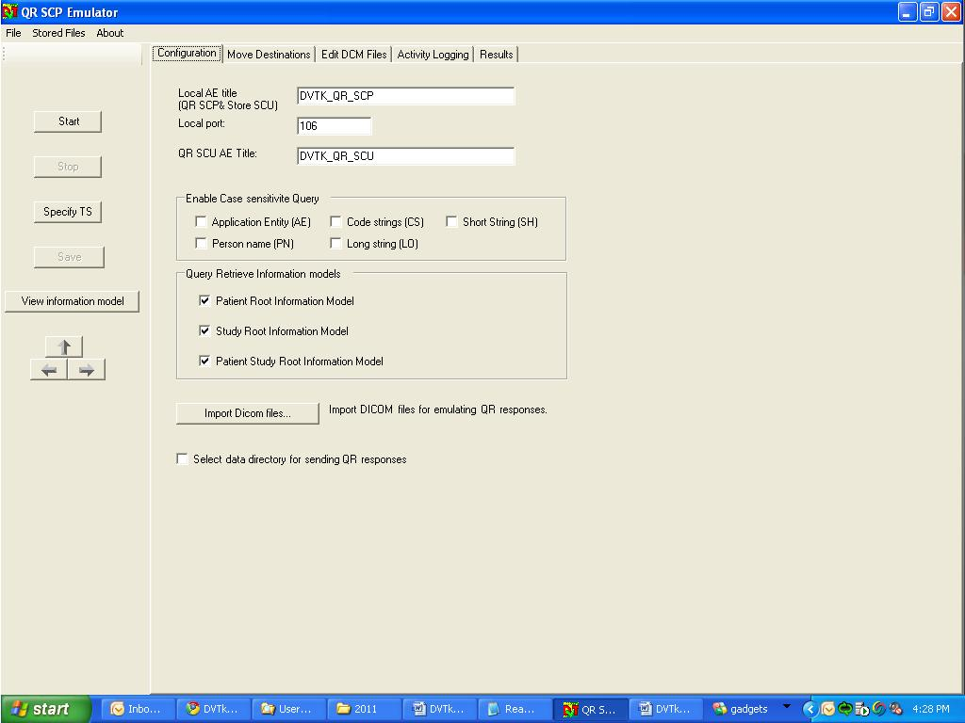

The Query Retrieve SCP Emulator start up window contains the following sections:

## Menu bar

From the Menu bar the following file options can be selected to control the Query Retrieve SCP Emulator:

**File:**

* **Config File**
  + Load
  + Save As
* **Exit**

**Stored Files:**

* **Explore Validation Results…**
* **Options…**

**About:**

* **About Emulator**

## Tool Strip

The tool strip (present on the left hand side) contains the following short keys to control the QR SCP emulator process:

**Start**

Clicking this button will make the SCP emulator listen for incoming association requests .

**Stop**

Clicking this button will stop the emulator.

**Specify TS**

Clicking this button will display a box containing various transfer syntaxes. The user can select the Transfer Syntax which the emulator must support.

**Save**

Clicking this button will save the configured parameters to the emulator’s session file (QR_SCP.ses)

**View Information Model**

Clicking this button will display the information model (constructed with the DICOM Files used for sending the emulator responses).

## Information Screen Selection

The following Tabs can be selected for display

* Configuration
* Move Destination
* Edit DCM Files
* Activity Logging
* Validation results

### Configuration

In the Configuration tab, the parameters for the communication with the SCP as well as the behavior of the SCP emulator can be configured. The configuration parameters are as follows:

#### General Configuration

* **AE title**

AE title used by the SCP emulator

* **Port number**

Listen port of the QR SCP emulator for incoming associations.

* **QR SCU title**

AE title used by the SCU

#### Case Sensitive Query

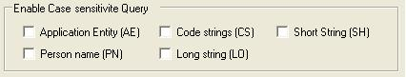

Via the check boxes, the user can select the VRs for which the emulator will support a case sensitive query.

#### Query Retrieve Information Models

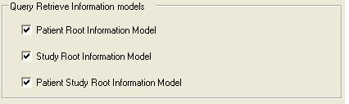

Via the check boxes, the user can select the Information Models which the Emulator will support.

#### Data Directory

* **Select Data Directory for sending QR Responses**

The user can select the data directory containing the DICOM Files which are used to emulate the responses of the emulator to Query/Retrieve requests. The default directory is:

C:\Documents and Settings\My Documents\DVTk\Query Retrieve SCP Emulator\Data\Query Retrieve

* **Import DICOM Files**

The user can use this option to import additional DICOM files to the Data Directory used for sending QR responses.

#### Optional Attributes in the Information Model

The DICOM conformance defines, any attribute can be an optional attributes in the QR information model. DVT-QR emulator provides an option to add custom optional attribute in the information model to test your SUT (SCU) against any attribute level query

Steps to add attributes to information model

*To add Series date (0008, 0021) in the series entity,*

* Click the  in QR emulator configuration tab
* In the opened text file, Go to the ------->Series Information Entity<-------
* Below that add only attribute tag  0008,0021. One attribute per line. You can add ‘n’ number of attributes in each level.

**------->Series Information Entity<-------**

**0008, 0021 ## series date**

**#0008,0031 ##Commented attribute**

**0018,1030**

**0008,103E**

**0018,0015**

**---------End of Series---------**

* Add ‘ **#**’ before attribute to unselect an attribute from information model
* Add **##** after the attribute to add comments
* Save and close the file.
* Now you can see the newly added attributes in the information model
* Now QR emulator supports following non-dataset attributes as well,
  + Modalities in study
  + Number of patient related studies
  + Number of patient related series
  + Number of patient related instance
  + Number of study related series
  + Number of study related instances
  + Number of series related instances

#### Configurable Timeout

To test the timeout of the SUT, Now QR emulator provides the configurable timeout for the QR Emulator. This can be configured in the Configuration tab



### Move Destinations

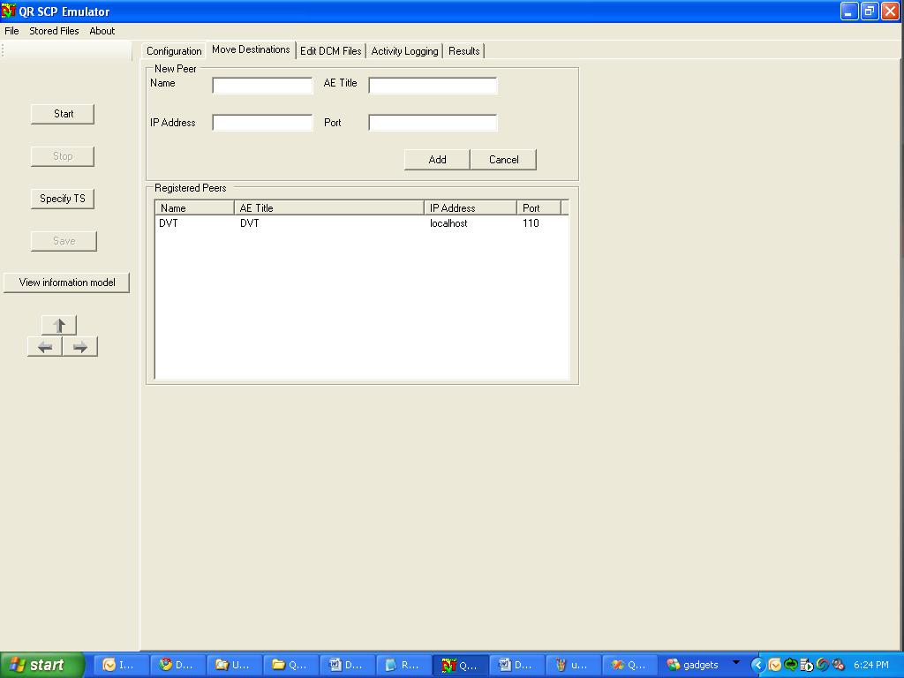

In the Move Destination Tab, the user can add new hosts as destinations for a C-Move Request.

The user fills in values for the following fields before clicking on “Add”.

**Name:**  Name of the new destination

**AE Title:** The AE Title of the Move Destination Host

**IP Address:** The IP Address of the Move Destination Host

**Port:** The port on which the Move Destination Host will be listening to incoming Storage Request

* When the user clicks on “Add”, the peer is registered and appears in the “List of Registered Peers” as shown above.
* By right-clicking any added destination, you can get more options for editing, echo etc,. As shown below,

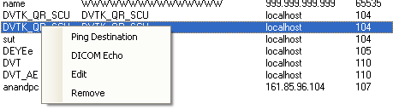

**Remark: All configuration settings in the Configuration and Move destination tabs can be saved by using the File menu option “Config File->Save As”. The system writes the config settings into two separate xml files in a user defined location. With the “Config File-> Load” function, the configuration files can be imported into the QR SCP emulator again.**

### Edit DCM Files

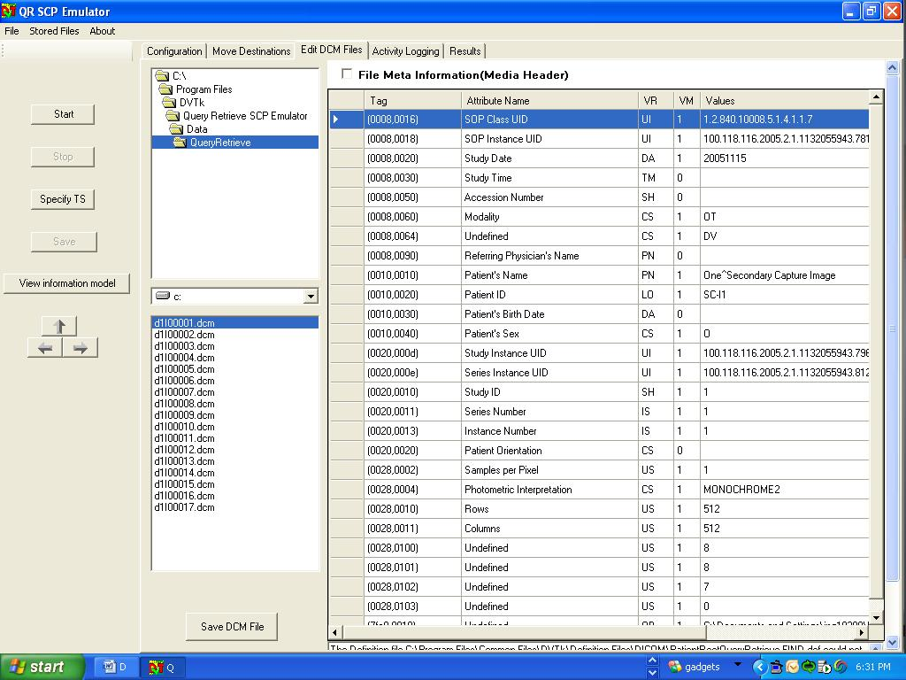

The DICOM Files used for emulating the QR responses can be edited using the Editor shown above.

To let the Query/Retrieve emulator generate random digits in attribute values, insert the character '@' in attribute values (use the "Edit Dicom Files..." button for this).When the Query/Retrieve emulator is started, each '@' will be replaced by a random digit (0-9). Multiple '@' characters may be inserted next to each other in attribute values to create a large random number. When the Query/Retrieve emulator is stopped and started again, these random digits will be newly generated. It is only possible to insert the '@' character in attributes with the following VR's:

* AE (Application Entity)
* AS (Age String)
* CS (Code String)
* DA (Date)
* DS (Decimal String)
* DT (Date Time)
* IS (Integer String)
* LO (Long String)
* PN (Person Name)
* SH (Short String)
* TM (Time)
* UI (Unique Identifier)

### Logging

After the SCP emulator has been started, the log window becomes automatically active and shows the progress of the emulator operation.

An example of log information is given in the screen capture below:

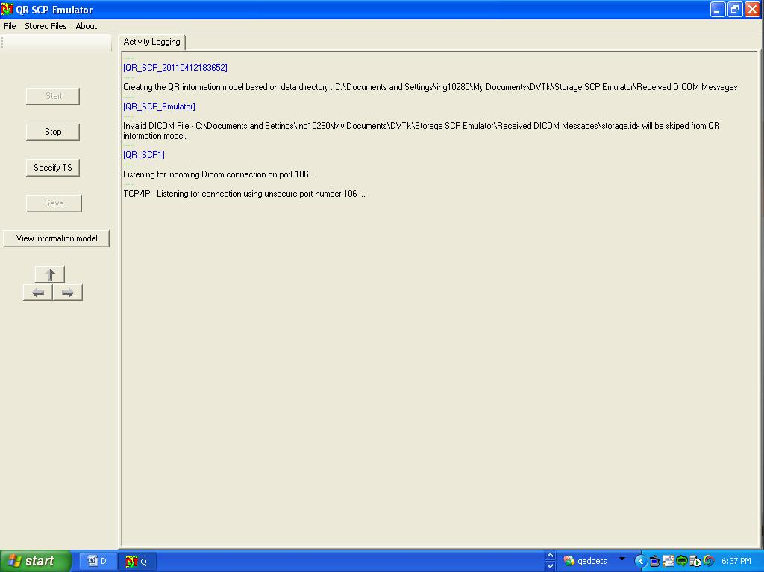

### Validation results

The validation results of all received DICOM messages and data objects are displayed.

**Validation results example:**

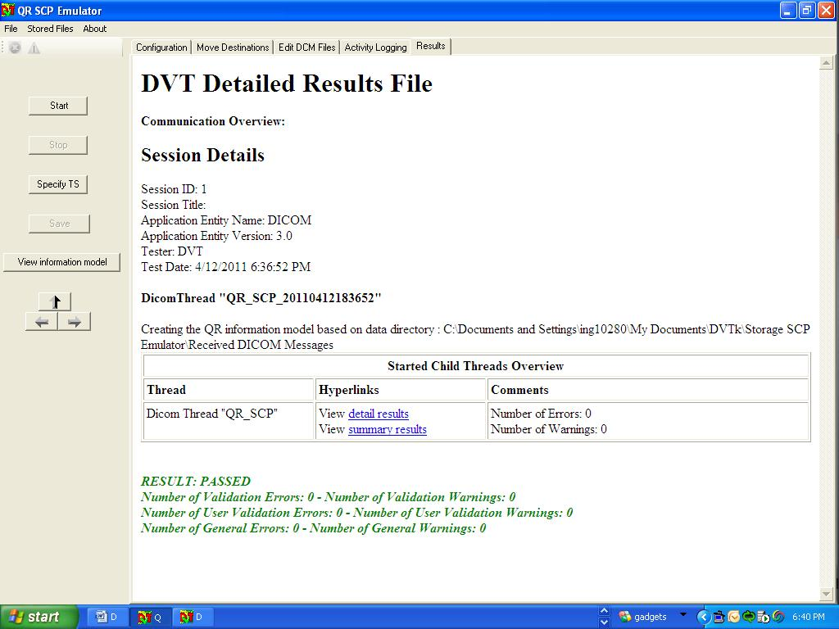

### Store Files functionality

User can configure/explore the result and data directory for emulator by using this option. The screen shot is as shown below:

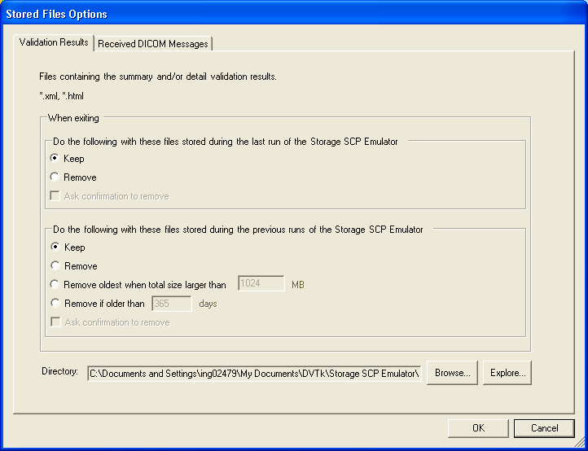

**Validation Results Tab**

With the “Browse” button, a directory can be selected for the storage of the result files.

The default result directory will be:

**On Windows XP and Server 2003 -** C:\Documents and Settings\username\My D ocuments\DVTk\Query Retrieve SCP Emulator\Results

**On Windows Vista and Windows 7 -**  C:\Users\username\My Documents\DVTk\Query Retrieve SCP Emulator\Results

With the “Explore” button, Windows explorer is started and shows the contents of the result directory.

**Cleanup of Result and Received DICOM message files**

Various options are provided for storing old result (xml/html) files and DICOM message (*.dcm) files when application exits or for previous runs as shown in above screen shot.

# Supported DICOM SOP Classes

The DVT Query Retrieve SCP emulator supports the SOP classes that are listed in the table below:

|  |  |
| --- | --- |
| 1.2.840.10008.5.1.4.1.2.1.1 | Patient Root Query-Retrieve Information Model – Find |
| 1.2.840.10008.5.1.4.1.2.1.2 | Patient Root Query-Retrieve Information Model – Move |
| 1.2.840.10008.5.1.4.1.2.1.3 | Patient Root Query-Retrieve Information Model – Get |
| 1.2.840.10008.5.1.4.1.2.2.1 | Study Root Query-Retrieve Information Model – Find |
| 1.2.840.10008.5.1.4.1.2.2.2 | Study Root Query-Retrieve Information Model – Move |
| 1.2.840.10008.5.1.4.1.2.2.3 | Study Root Query-Retrieve Information Model - Get |
| *1.2.840.10008.5.1.4.1.2.3.1* | *Patient-Study Only Query-Retrieve Information Model – Find(Retired)* |
| *1.2.840.10008.5.1.4.1.2.3.2* | *Patient-Study Only Query-Retrieve Information Model - Move(Retired)* |
| *1.2.840.10008.5.1.4.1.2.3.3* | *Patient-Study Only Query-Retrieve Information Model - Get(Retired)* |
| 1.2.840.10008.5.1.4.1.1.1 | Computed Radiography Image Storage |
| 1.2.840.10008.5.1.4.1.1.1.1 | Digital X-Ray Image Storage – For Presentation |
| 1.2.840.10008.5.1.4.1.1.1.1.1 | Digital X-Ray Image Storage – For Processing |
| 1.2.840.10008.5.1.4.1.1.1.2 | Digital Mammography X-Ray Image Storage – For Presentation |
| 1.2.840.10008.5.1.4.1.1.1.2.1 | Digital Mammography X-Ray Image Storage – For Processing |
| 1.2.840.10008.5.1.4.1.1.1.3 | Digital Intra-oral X-Ray Image Storage – For Presentation |
| 1.2.840.10008.5.1.4.1.1.1.3.1 | Digital Intra-oral X-Ray Image Storage – For Processing |
| 1.2.840.10008.5.1.4.1.1.2 | CT Image Storage |
| 1.2.840.10008.5.1.4.1.1.2.1 | Enhanced CT Image Storage |
| *1.2.840.10008.5.1.4.1.1.3* | *Ultrasound Multi-frame Image Storage (Retired)* |
| 1.2.840.10008.5.1.4.1.1.3.1 | Ultrasound Multi-frame Image Storage |
| 1.2.840.10008.5.1.4.1.1.4 | MR Image Storage |
| 1.2.840.10008.5.1.4.1.1.4.1 | Enhanced MR Image Storage |
| 1.2.840.10008.5.1.4.1.1.4.2 | MR Spectroscopy Storage |
| *1.2.840.10008.5.1.4.1.1.5* | *Nuclear Medicine Image Storage (Retired)* |
| *1.2.840.10008.5.1.4.1.1.6* | *Ultrasound Image Storage (Retired)* |
| 1.2.840.10008.5.1.4.1.1.6.1 | Ultrasound Image Storage |
| 1.2.840.10008.5.1.4.1.1.7 | Secondary Capture Image Storage |
| 1.2.840.10008.5.1.4.1.1.7.1 | Multi-frame Single Bit Secondary Capture Image Storage |
| 1.2.840.10008.5.1.4.1.1.7.2 | Multi-frame Grayscale Byte Secondary Capture Image Storage |
| 1.2.840.10008.5.1.4.1.1.7.3 | Multi-frame Grayscale Word Secondary Capture Image Storage |
| 1.2.840.10008.5.1.4.1.1.7.4 | Multi-frame True Color Secondary Capture Image Storage |
| *1.2.840.10008.5.1.4.1.1.8* | *Standalone Overlay Storage (Retired)* |
| *1.2.840.10008.5.1.4.1.1.9* | *Standalone Curve Storage (Retired)* |
| 1.2.840.10008.5.1.4.1.1.9.1.1 | 12-lead ECG Waveform Storage |
| 1.2.840.10008.5.1.4.1.1.9.1.2 | General ECG Waveform Storage |
| 1.2.840.10008.5.1.4.1.1.9.1.3 | Ambulatory ECG Waveform Storage |
| 1.2.840.10008.5.1.4.1.1.9.2.1 | Hemodynamic Waveform Storage |
| 1.2.840.10008.5.1.4.1.1.9.3.1 | Cardiac Electrophysiology Waveform Storage |
| 1.2.840.10008.5.1.4.1.1.9.4.1 | Basic Voice Audio Waveform Storage |
| *1.2.840.10008.5.1.4.1.1.10* | *Standalone Modality LUT Storage (Retired)* |
| *1.2.840.10008.5.1.4.1.1.11* | *Standalone VOI LUT Storage (Retired)* |
| 1.2.840.10008.5.1.4.1.1.11.1 | Grayscale Softcopy Presentation State Storage SOP Class |
| 1.2.840.10008.5.1.4.1.1.12.1 | X-Ray Angiographic Image Storage |
| 1.2.840.10008.5.1.4.1.1.12.2 | X-Ray Radiofluoroscopic Image Storage |
| *1.2.840.10008.5.1.4.1.1.12.3* | *X-Ray Angiographic Bi-Plane Image Storage (Retired)* |
| 1.2.840.10008.5.1.4.1.1.20 | Nuclear Medicine Image Storage |
| 1.2.840.10008.5.1.4.1.1.66 | Raw Data Storage |
| 1.2.840.10008.5.1.4.1.1.66.1 | Spatial Registration Storage |
| 1.2.840.10008.5.1.4.1.1.66.2 | Spatial Fiducials Storage |
| *1.2.840.10008.5.1.4.1.1.77.1* | *VL Image Storage (Retired)* |
| *1.2.840.10008.5.1.4.1.1.77.2* | *VL Multi-frame Image Storage (Retired)* |
| 1.2.840.10008.5.1.4.1.1.77.1.1 | VL Endoscopic Image Storage |
| 1.2.840.10008.5.1.4.1.1.77.1.1.1 | Video Endoscopic Image Storage |
| 1.2.840.10008.5.1.4.1.1.77.1.2 | VL Microscopic Image Storage |
| 1.2.840.10008.5.1.4.1.1.77.1.2.1 | Video Microscopic Image Storage |
| 1.2.840.10008.5.1.4.1.1.77.1.3 | VL Slide-Coordinates Microscopic Image Storage |
| 1.2.840.10008.5.1.4.1.1.77.1.4 | VL Photographic Image Storage |
| 1.2.840.10008.5.1.4.1.1.77.1.4.1 | Video Photographic Image Storage |
| 1.2.840.10008.5.1.4.1.1.77.1.5.1 | Ophthalmic Photography 8 Bit Image Storage |
| 1.2.840.10008.5.1.4.1.1.77.1.5.2 | Ophthalmic Photography 16 Bit Image Storage |
| 1.2.840.10008.5.1.4.1.1.77.1.5.3 | Stereometric Relationship Storage |
| 1.2.840.10008.5.1.4.1.1.88.11 | Basic Text SR |
| 1.2.840.10008.5.1.4.1.1.88.22 | Enhanced SR |
| 1.2.840.10008.5.1.4.1.1.88.33 | Comprehensive SR |
| 1.2.840.10008.5.1.4.1.1.88.50 | Mammography CAD SR |
| 1.2.840.10008.5.1.4.1.1.88.59 | Key Object Selection Document |
| 1.2.840.10008.5.1.4.1.1.88.65 | Chest CAD SR |
| 1.2.840.10008.5.1.4.1.1.104.1 | Encapsulated PDF Storage |
| 1.2.840.10008.5.1.4.1.1.128 | Positron Emission Tomography Image Storage |
| *1.2.840.10008.5.1.4.1.1.129* | *Standalone PET Curve Storage (Retired)* |
| 1.2.840.10008.5.1.4.1.1.481.1 | RT Image Storage |
| 1.2.840.10008.5.1.4.1.1.481.2 | RT Dose Storage |
| 1.2.840.10008.5.1.4.1.1.481.3 | RT Structure Set Storage |
| 1.2.840.10008.5.1.4.1.1.481.4 | RT Beams Treatment Record Storage |
| 1.2.840.10008.5.1.4.1.1.481.5 | RT Plan Storage |
| 1.2.840.10008.5.1.4.1.1.481.6 | RT Brachy Treatment Record Storage |
| 1.2.840.10008.5.1.4.1.1.481.7 | RT Treatment Summary Record Storage |
| 1.2.840.10008.1.20.1 | Storage Commitment Push model |

Table 4-1 supported Query/Retrieve & Storage SOP classes

# Supported transfer syntaxes

The transfer syntaxes supported by the SCP emulator are listed in the table below.

|  |  |
| --- | --- |
| 1.2.840.10008.1.2 | Implicit VR Little Endian |
| 1.2.840.10008.1.2.1 | Explicit VR Little Endian |
| 1.2.840.10008.1.2.2 | Explicit VR Big Endian |

Table 5-1: Supported transfer syntaxes

Note: This table is not be confused with the transfer syntax of the DICOM image being retrieved or moved. The transfer syntaxes mentioned above are used while sending/receiving the service elements. The emulator supports Query/Retrieve of Move of a DICOM Image encoded in all transfer syntaxes defined in the DICOM Standard.